NAME: KARIUKI LISPER WAIGUMO

REG NO: BSCCS/2024/60096

COURSE/CLASS: BACHELORS OF SCIENCE IN COMPUTER SCIENCE

UNIT CODE: BIT3208

UNIT NAME: ADVANCED WEB DESIGN AND DEVELOPMENT

LECTURERER NAME: MICHAEL NYORO

SEMESTER/ ACADEMIC YEAR: SEMESTER 6

PROJECT DETAILS

PROJECT TITLE: LISPER/CHUM STORE

SELECTED TECHNOLOGIES: 1. PHP & SQL

GITHUB REPOSITORY LINK:

Upload files · risperkariuki068-png/Chum-Lisper-Store

TABLE OF CONTENTS

Table of Contents
WEEK 1: LOCAL ENVIRONMENT SETUP 6
Title: Installation and Testing of Local Development Environment 6
Fig 1: XAMPP 6
Fig 2: Apache and MySQL Running (Screenshot from XAMPP Control Panel) 7
Fig 3: Localhost Test page (Screenshot browser running localhost) 7
Fig 4: Hello World Test (Screenshot of first PHP or HTML page) 8
Figure 5: Database Connection Test (screenshot showing successful DB connection) 8
WEEK 2: Wireframes and GUI Design 9
Title: User Interface Planning and System Design 9
Fig 1: Hand- Drawn Wireframe 9
Fig 2: Dashboard Layout Design 10
Figure 3: Mobile View Mockup 11
Fig 4: Color Theme and Navigation Structure 12
Fig 5: GUI prototype in Figma/ Canva/ Draw.io 13
Week 3: JavaScript and PHP Basics 14
Title: Frontend Interaction and Backend Foundations 14
Fig 1: JavaScript Form Validation 14
Fig 2: Password Strength Checker 15
Fig 3: PHP Syntax Practice 16
Fig 4: Database Connection Script 16
Fig 5: Dynamic User Input Handling 17
Week 4: Dynamic Backend Processing, Authentication and Session Management 18
Title: System Implementation Summary 18
Fig 1: Login System Development 18
Fig 2: Login Page Interface 19
Fig 3: Database Connection Script 20
Fig 4: Users table in phpMyAdmin 20
Fig 5: Session Management 21
Week 5: Building Data-Driven Systems using Databases 22
Task 1: Introduction to Databases 22
Fig 1: Php showing the database successfully created. 22
Fig 2: Table Creation for users with ID, Username, and password fields 22
Fig 3: Insert Query adding a new customer 23
Fig 4: View records query displaying stored data 24
Fig 5: Edit query Updating User Information 25
Fig 6: Delete Query Removing a record successfully (codes) 26
WEEK 6 27
Title: Database Integration and CRUD functions 27
Fig 1: Connect to MySQL using db.php 27
Fig 2: CREATE Operations to Insert Products Records 27
Fig 3: READ Operation to Display Products Records 27
Fig 4: UPDATE Operation to edit products Records 28
Fig 5: DELETE Operation to delete product record 28
Reflection: 28
WEEK 7 29
Title: User Authentication and Session Management 29
Fig 1: Creating a User’s Table 29
Fig 2: User Registration System 30
Registration form 30
Fig 3: Processing Registration 31
Fig 4: Why use of Hash Passwords 31
Explanation for use of Harsh: 31
Task: Login System 32
Fig 1: Login Form 32
Fig 2: Login Processing 33
Task: Session Management 33
Fig 1: Starting a Session 33
Fig 2: Creating Session Variables 34
Fig 3: Protecting Pages 34
Task: Logout System 36
Fig 1: Logout Script 36
Reflection: 36
WEEK 8 37
Title: Responsive Web Design and Mobile- First Development 37
Task 1: Create a Responsive Personal Profile Page 37
Fig 1: Desktop Personal Profile View 37
Fig 2: Mobile View 38
Justification 38
Task 2: Build a Responsive Product Showcase 39
Fig 1: Desktop State 39
Fig 2: Tablet State 39
Fig 3: Mobile View 40
Reflection 40
WEEK 9: Java Web Services: Servlet Lifecycle, Session Management, and Cookies. 41
Practical Activity 41
Fig 1: The Login Step 41
Fig 2: The Welcome Dashboard Step 42
Fig 3: The Logout Step 42
WEEK 10: DYNAMIC HTML GENERATION AND JDBC BASICS 43
Practical Activity 43
Fig 1: The Database Setup(phpMyAdmin) 43
Fig 2: Form Submission (Insert Record) 44
Fig 3: Dynamic Record Display (Read Operation) 45
Fig 4: The Backend Logic 45
WEEK 11: BUILDING DYNAMIC PAGES WITH FULL DATABASE INTEGRATION 46
Practical Activity 46
Fig 1: Search Feature 46
Fig 2: UI Enhancement CSS 46
WEEK 12: ASP.NET CONCEPTS: OBJECT MODEL, CONTROL STRUCTURES, SESSION MANAGEMENT AND DEVELOPING ASP.NET WEB FORMS 47
Practical Activity 47
Fig 1: Registration & Login Screens 47
Fig 2: Form Drop Down Selector 49
Figure 3: Main Data Table 50
Fig 4: System Status Management 50
Fig 5: Session Management Proof 51
5.1 Admin dashboard 51
WEEK 13: COM, COBRA, RMI, LDAP AND SEARCH ENGINES 52
Practical Activity 52
Fig 1: Core LDAP Function 52
Fig 2: Multi-Criteria SQL Search Query 53
Fig 3: Testing Category/ Course Filtering (Browser) 54
Fig 4: Testing ID/Registration Filtering(Browser) 54
WEEK 14: WEBSITE TESTING, PUBLISHING AND MAINTENANCE 55
Practical Activity 55
Fig: Automated Test Script (VS Code) 55
Fig 2: GitHub Repository Status (Browser) 56
Fig 3: Fully Functional Application (Browser) 57

WEEK 1: LOCAL ENVIRONMENT SETUP

Title: Installation and Testing of Local Development Environment

Fig 1: XAMPP
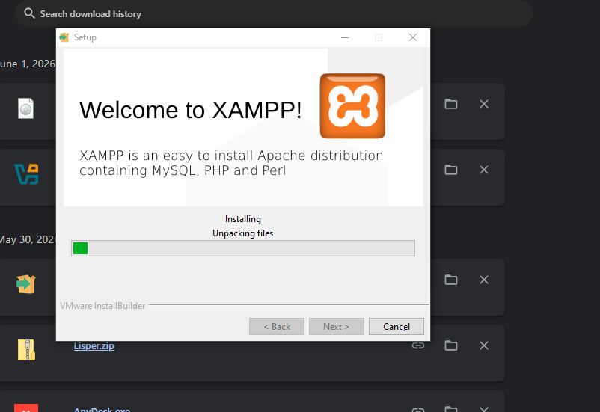

Fig 2: Apache and MySQL Running (Screenshot from XAMPP Control Panel)
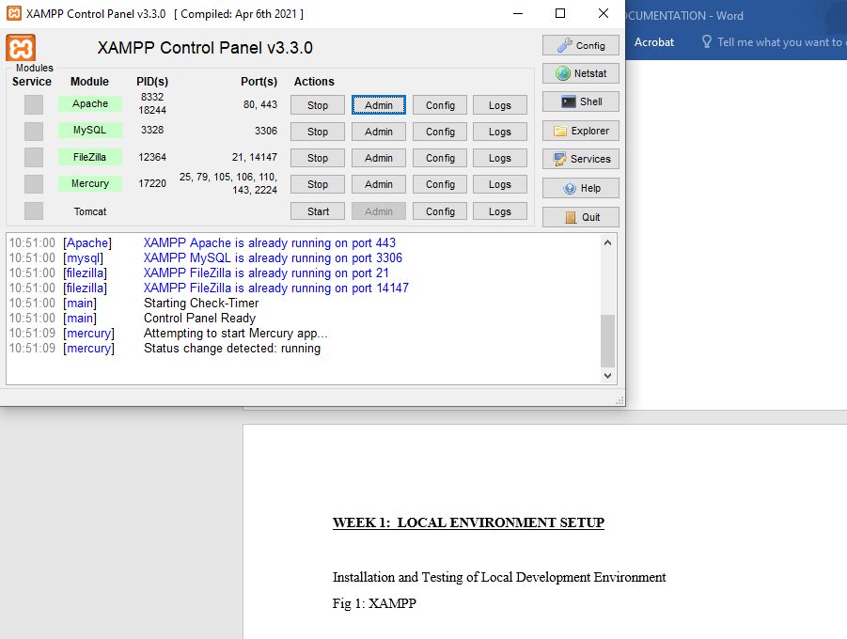

Fig 3: Localhost Test page (Screenshot browser running localhost)
I’m using fire fox to run the localhost.

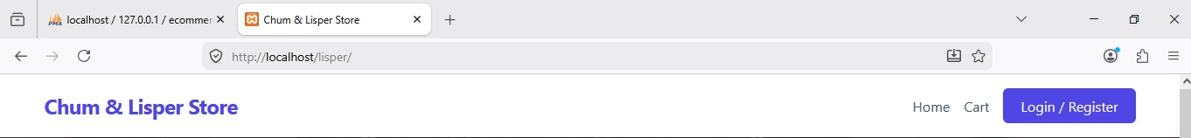

Fig 4: Hello World Test (Screenshot of first PHP or HTML page)
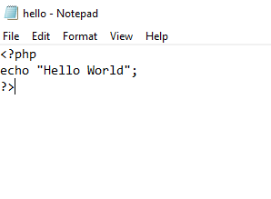

Figure 5: Database Connection Test (screenshot showing successful DB connection)
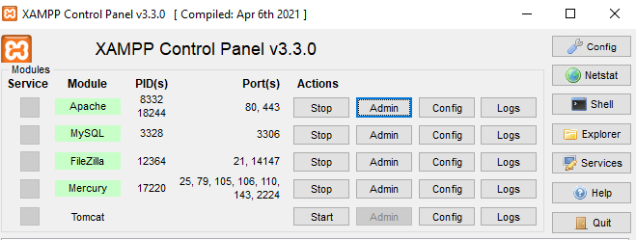
Reflection: Figure 5 shows the successful connection between PHP and MySQL. This confirms that Apache and MySQL services were properly configured in XAMPP.

WEEK 2: Wireframes and GUI Design

Title: User Interface Planning and System Design

Fig 1: Hand- Drawn Wireframe
(Login/Homepage)
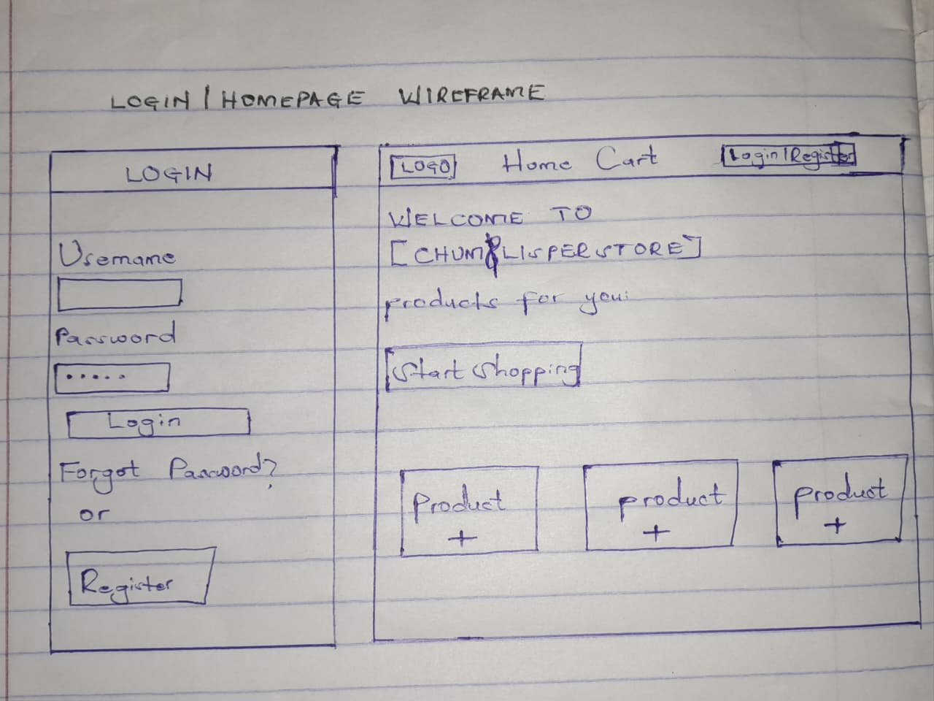

Fig 2: Dashboard Layout Design
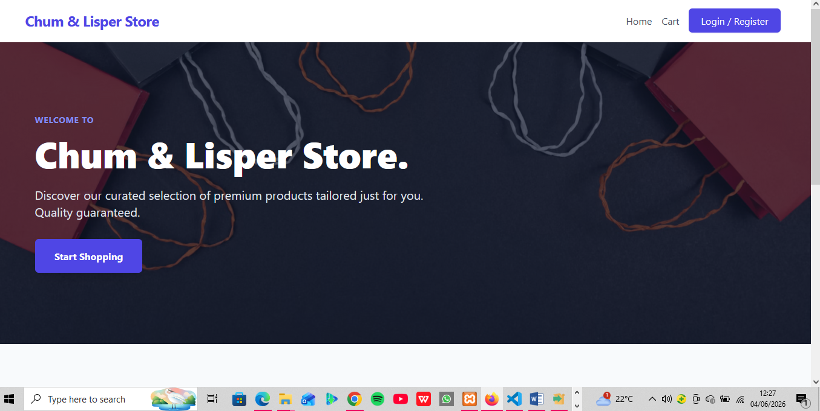

Figure 3: Mobile View Mockup
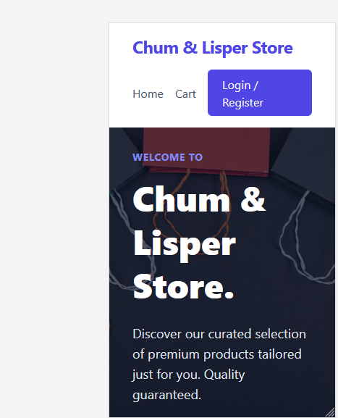

Fig 4: Color Theme and Navigation Structure


Fig 5: GUI prototype in Figma/ Canva/ Draw.io
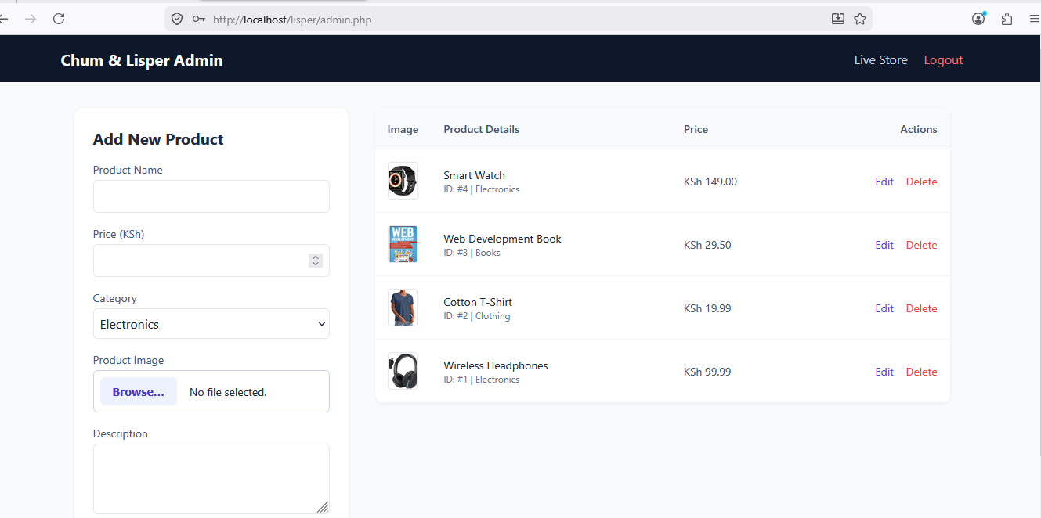

Reflection: The minimalist grid design was chosen for the Chum/Lisper store system to make browsing items clear and straightforward. To improve the user experience, I focused on reducing clutter so store admins and buyers wouldn't get overwhelmed. The navigation flow was planned to move users sequentially from selecting an item straight to the checkout page in as few clicks as possible. The system's intended users are everyday customers placing orders and store managers keeping track of stock, meaning the interface had to be simple, fast, and easy to learn.

Week 3: JavaScript and PHP Basics

Title: Frontend Interaction and Backend Foundations

Fig 1: JavaScript Form Validation
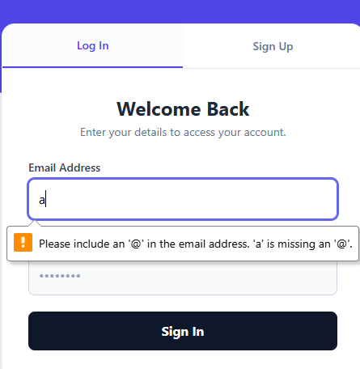

Fig 2: Password Strength Checker
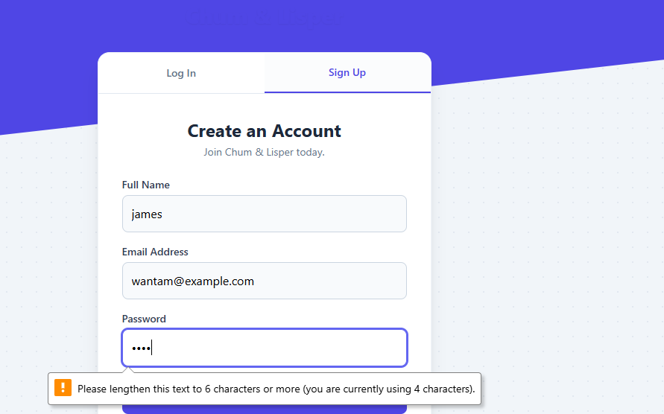

Fig 3: PHP Syntax Practice
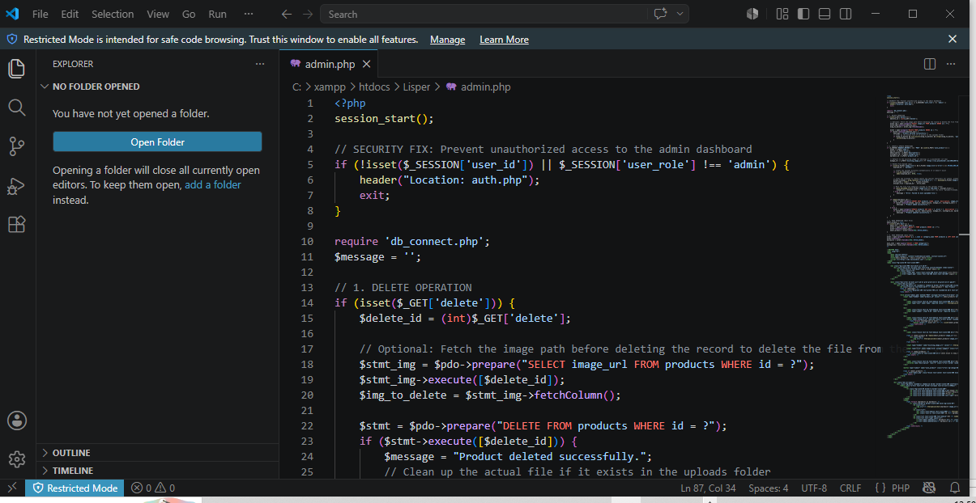

Fig 4: Database Connection Script


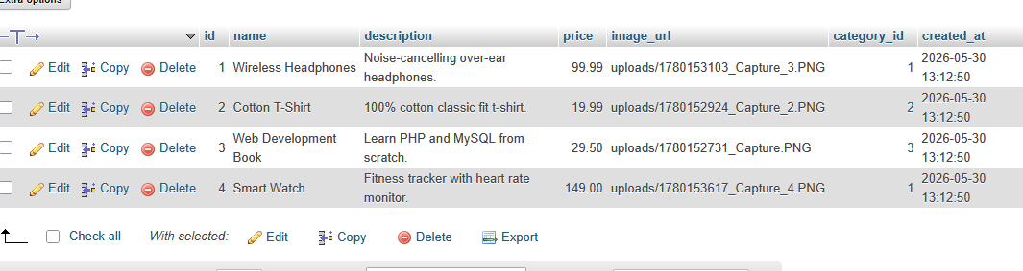

Fig 5: Dynamic User Input Handling
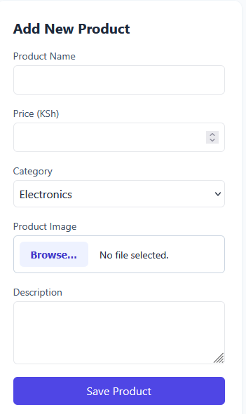
Reflection: This week involved implementing basic frontend and backend functionality for the Chum/Lisper store order-management system. JavaScript was used to validate order form inputs and prevent submission of empty fields, improving user experience before data is sent to the server. PHP was used to process order submissions and authenticate store credentials. The integration of JavaScript and PHP improved system reliability by ensuring proper data handling and validation before processing

Week 4: Dynamic Backend Processing, Authentication and Session Management

Title: System Implementation Summary

A login system was created to authenticate users before accessing the system.

Fig 1: Login System Development
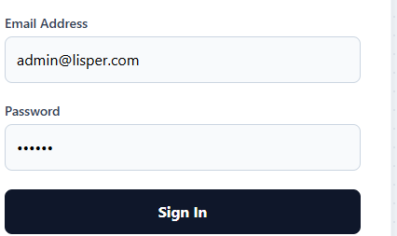

Fig 2: Login Page Interface
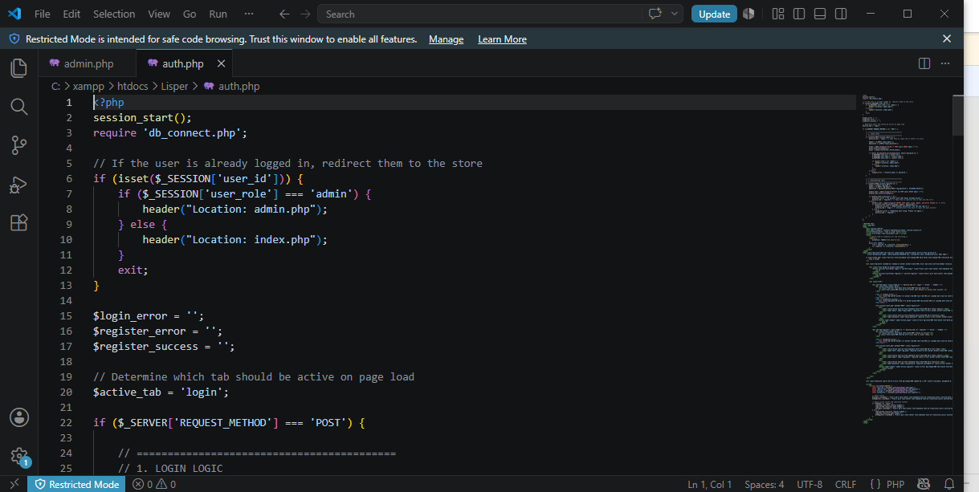

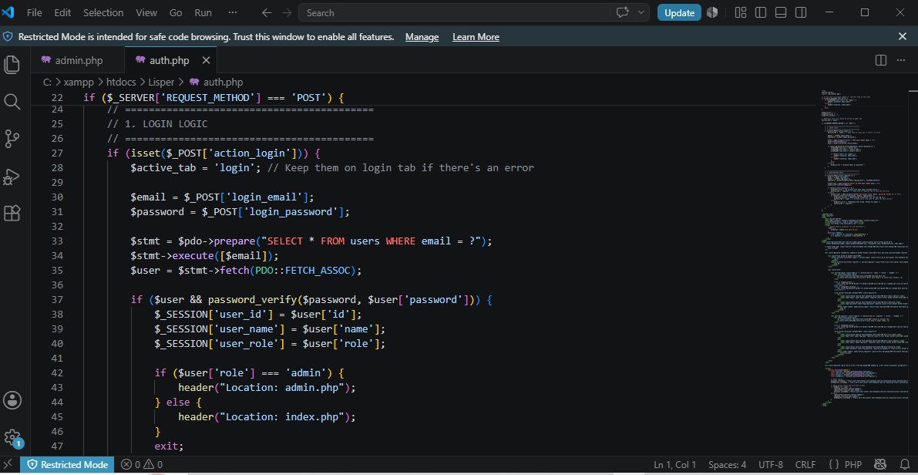

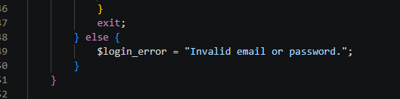

Fig 3: Database Connection Script
Users Table Created to store the user’s login details.
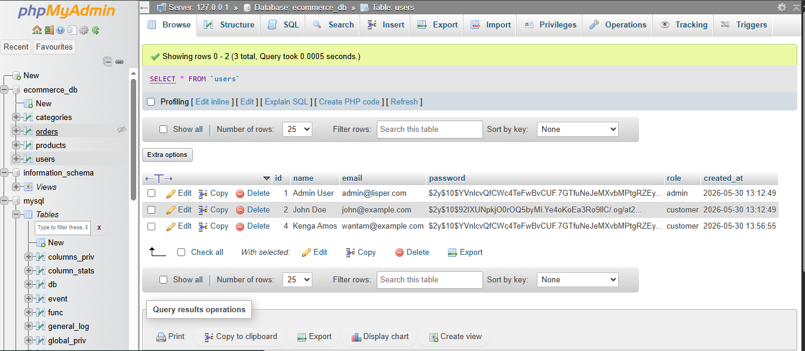

Fig 4: Users table in phpMyAdmin
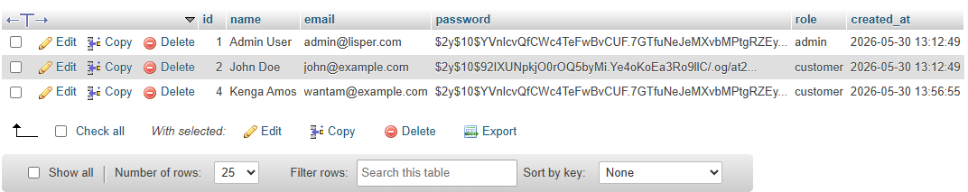

Fig 5: Session Management
To maintain user login state after successful authentication

Fig 6: Successful Login Session (Dashboard View)
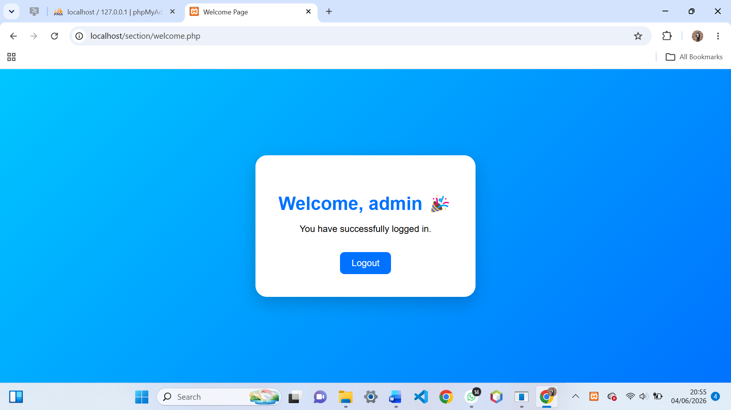

Reflection:
Week 4 focused on backend processing, authentication, and session management. A login system was successfully implemented using PHP and MySQL. Sessions were used to control access to the dashboard. Challenges included database connection errors and session handling issues which were resolved through debugging and testing.

Week 5: Building Data-Driven Systems using Databases

Task 1: Introduction to Databases

Fig 1: Php showing the database successfully created.
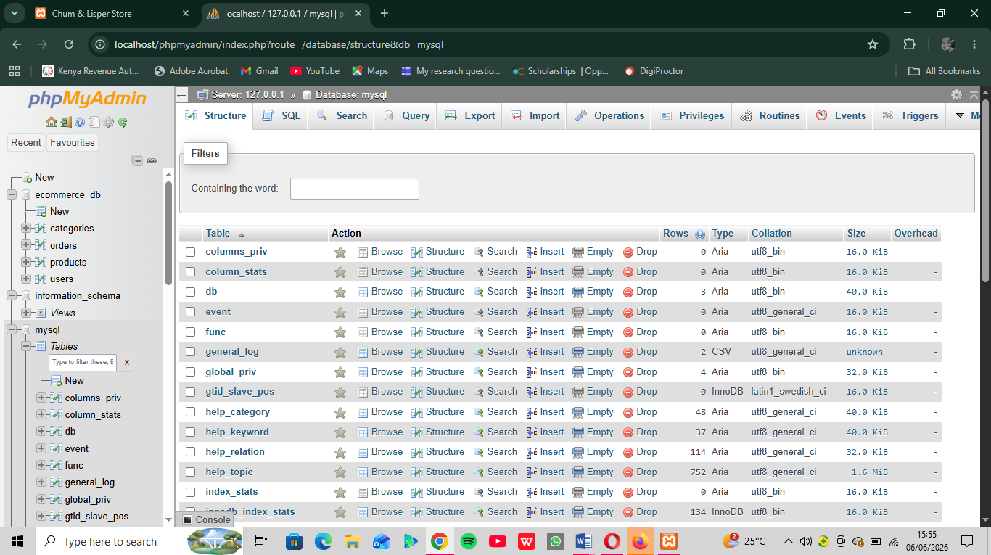

Fig 2: Table Creation for users with ID, Username, and password fields
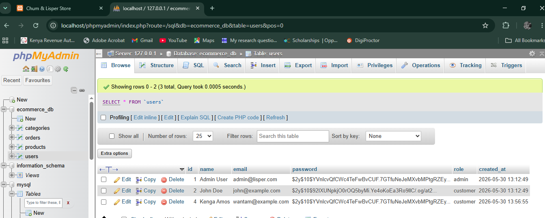

Fig 3: Insert Query adding a new customer
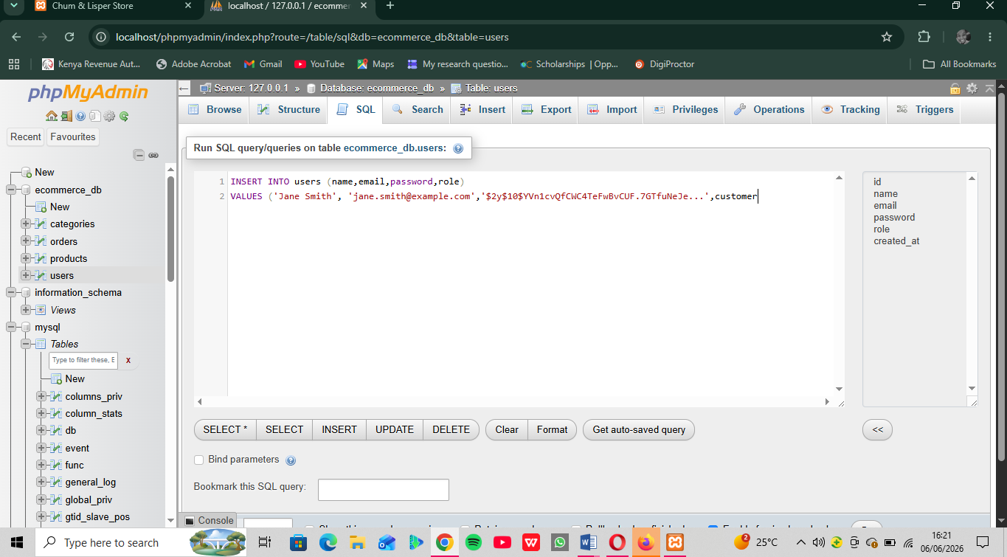

Fig 4: View records query displaying stored data
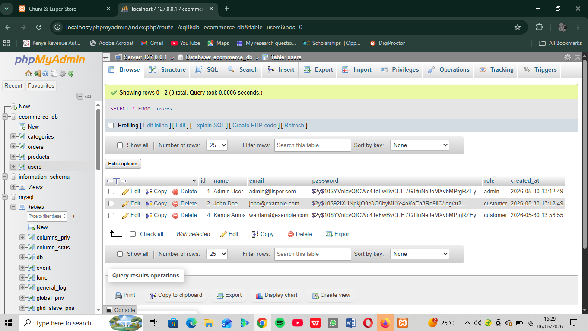
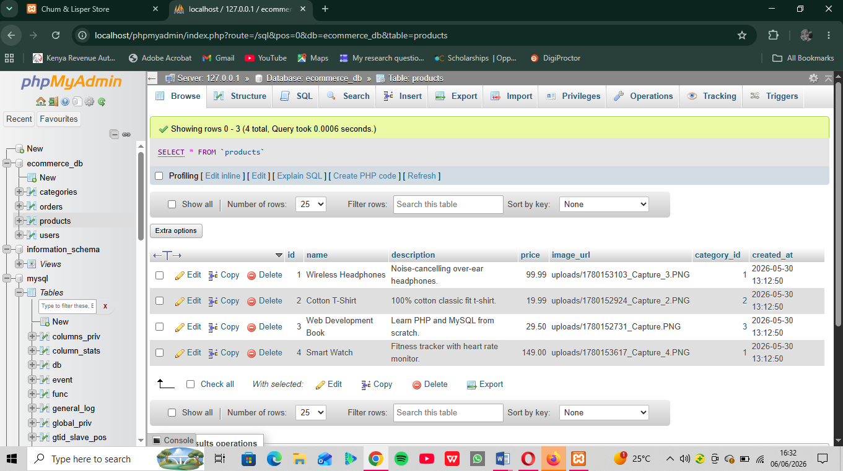

Fig 5: Edit query Updating User Information
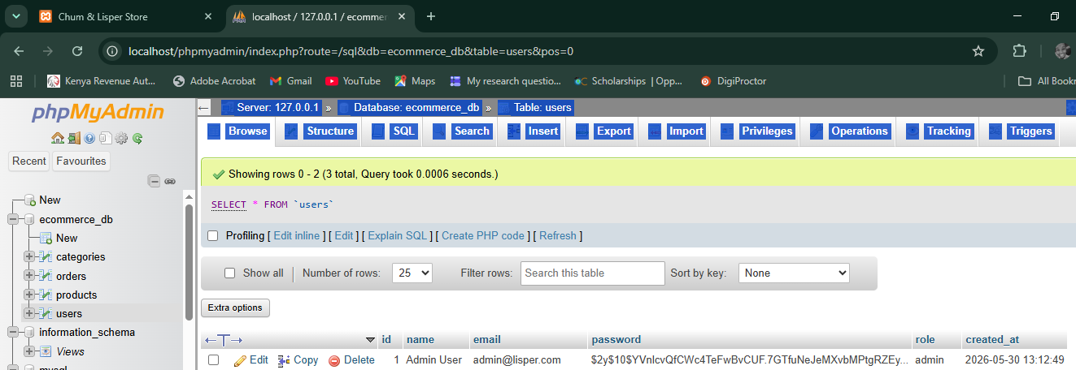
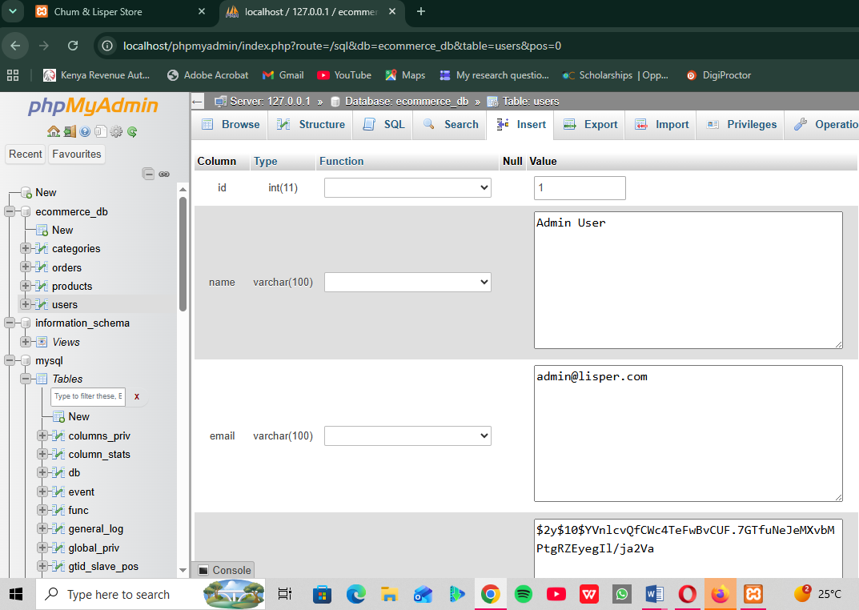

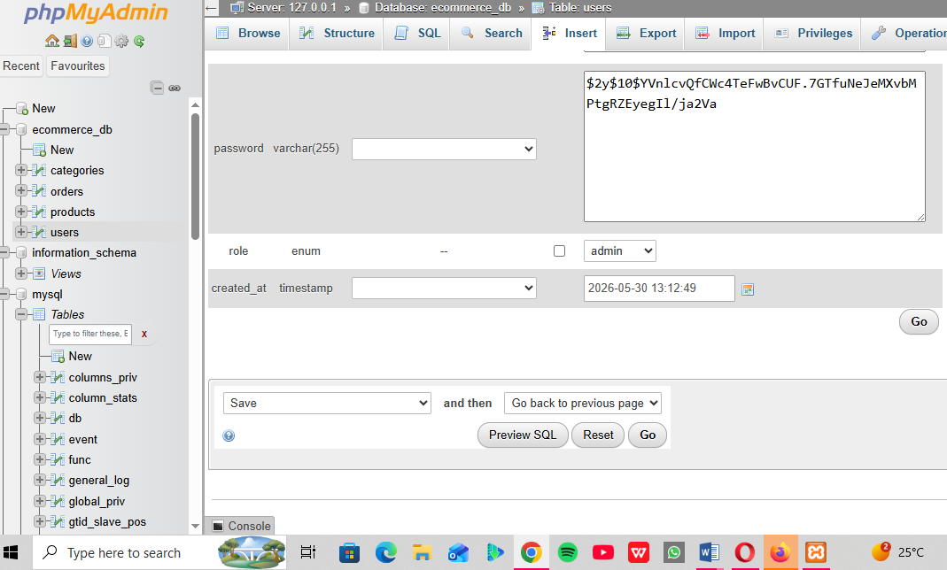

Fig 6: Delete Query Removing a record successfully (codes)

DELETE FROM users WHERE username= ‘admin’;

DELETE FROM products WHERE product name= ‘Smart Watch’;

DELETE FROM customer WHERE name= ‘Kenga Amos’;

Reflection: This week I learned how to build database-driven systems. Fig 1–3 show the creation of student, product, and authentication databases. Fig 4 demonstrates table setup for user credentials. CRUD operations (Fig 5–8) allowed me to add, view, edit, and delete records, proving full database functionality. These tasks taught me how backend systems manage persistent data and connect to frontend forms. The main challenge was ensuring queries executed correctly, which improved my understanding of SQL syntax and database integration with PHP.

WEEK 6

Title: Database Integration and CRUD functions

Fig 1: Connect to MySQL using db.php
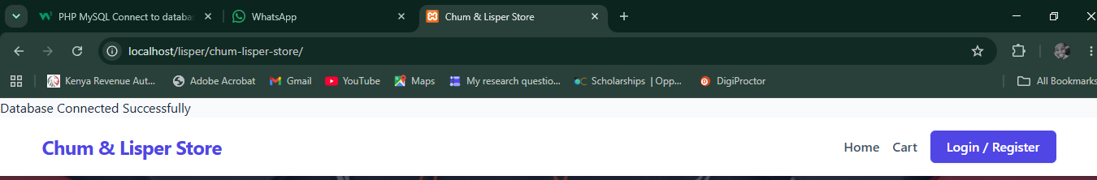

Fig 2: CREATE Operations to Insert Products Records
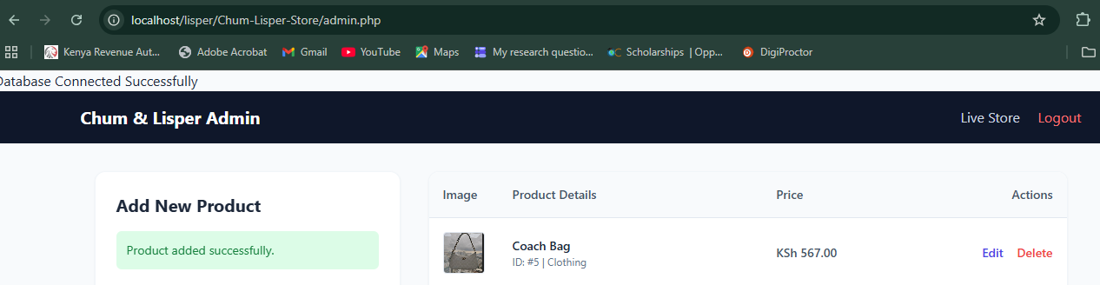

Fig 3: READ Operation to Display Products Records
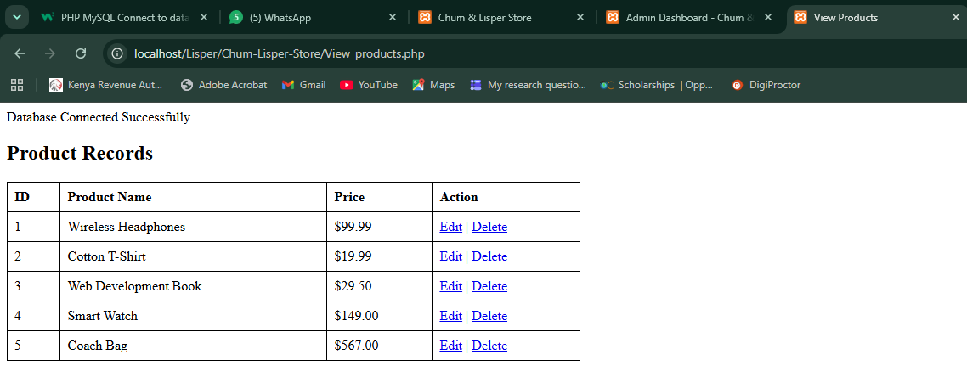

Fig 4: UPDATE Operation to edit products Records
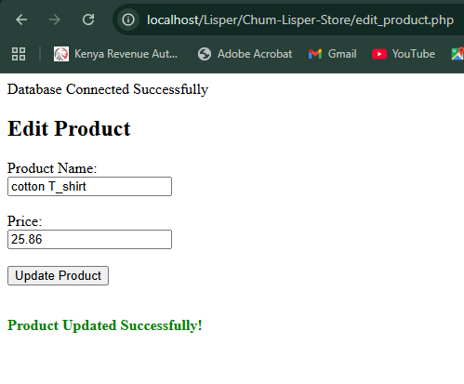

Fig 5: DELETE Operation to delete product record
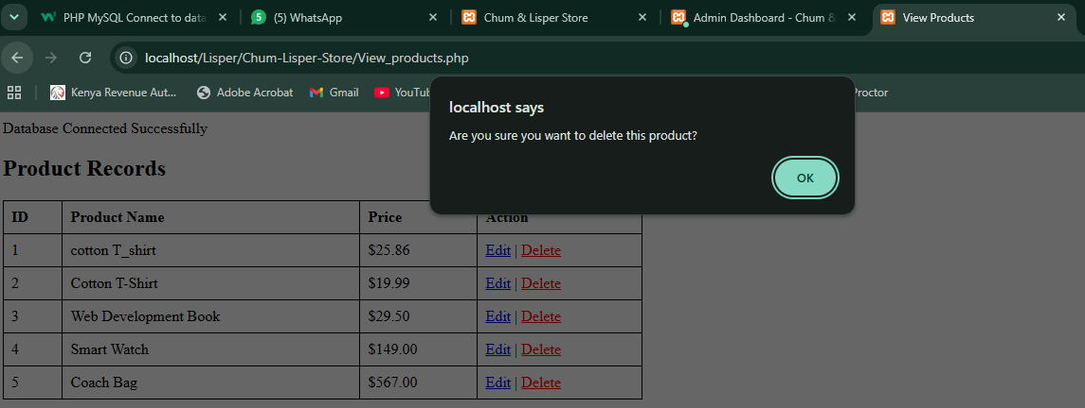

Reflection:
During week six, I integrated a secure MySQL database connection into my e-commerce system using PHP Data Objects (PDO) and developed core CRUD operations. I established a centralized configuration file to maintain organized connectivity before creating explicit user interfaces for managing store inventory. I structured input forms for product registration, generated clean HTML data tables to pull active database records, built editing panels to modify details safely, and deployed interactive JavaScript confirmation dialogs to intercept accidental data removal. This process solidified my understanding of how relational back-end records interact with dynamic full-stack user environments.

WEEK 7

Title: User Authentication and Session Management

Fig 1: Creating a User’s Table

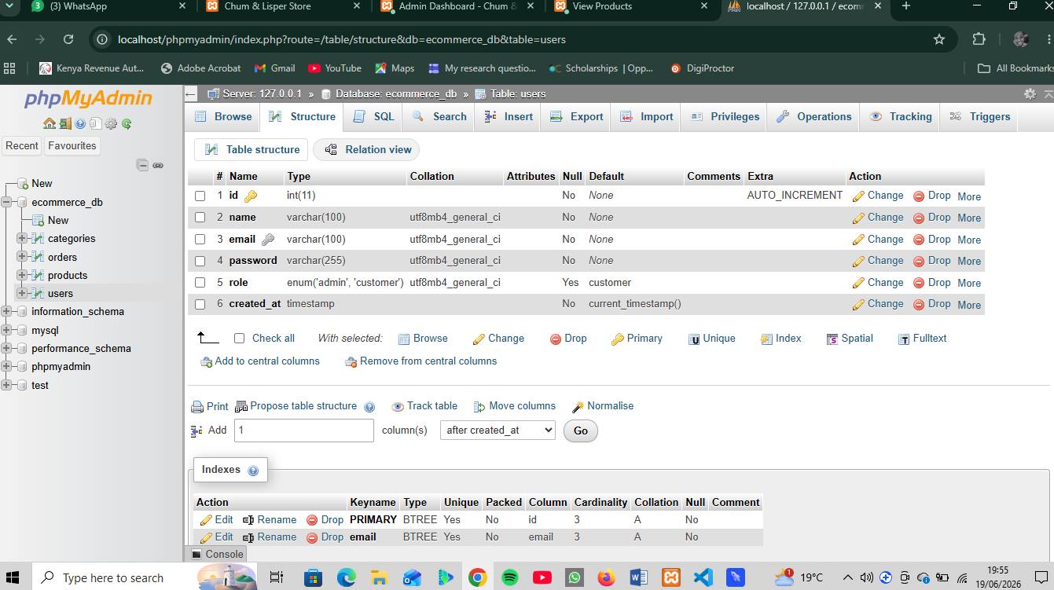

Fig 2: User Registration System

Registration form
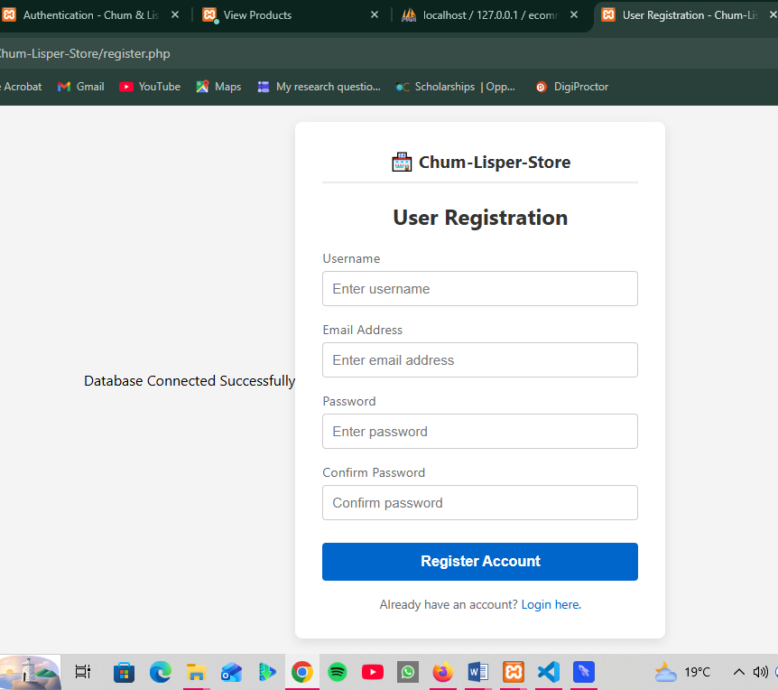

Fig 3: Processing Registration
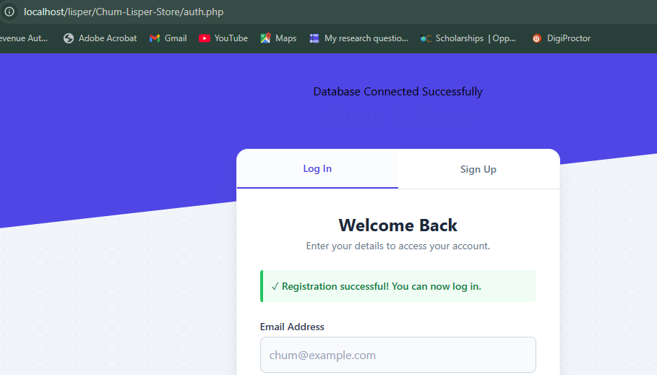

Fig 4: Why use of Hash Passwords
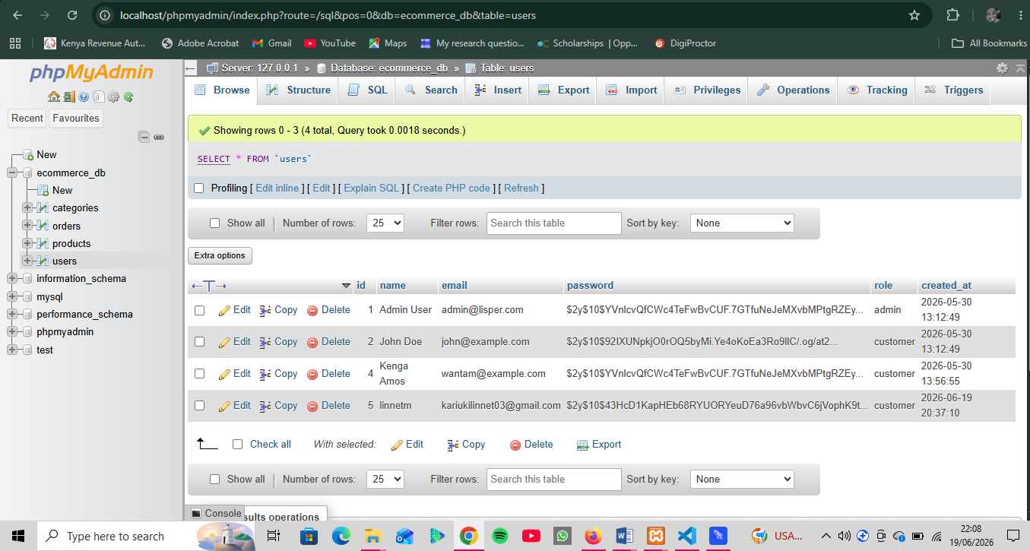

Explanation for use of Harsh:
In Fig 4 above: Database Storage of Hashed User Passwords
As shown in the screenshot above, user passwords are not saved in "plain text" (such as 12345 or mysecretpassword). Instead, the system processes them through PHP's native password_hash () function, converting them into an irreversible, unique 60-character cryptographic string (like $2y$10$X...).

Task: Login System

Fig 1: Login Form
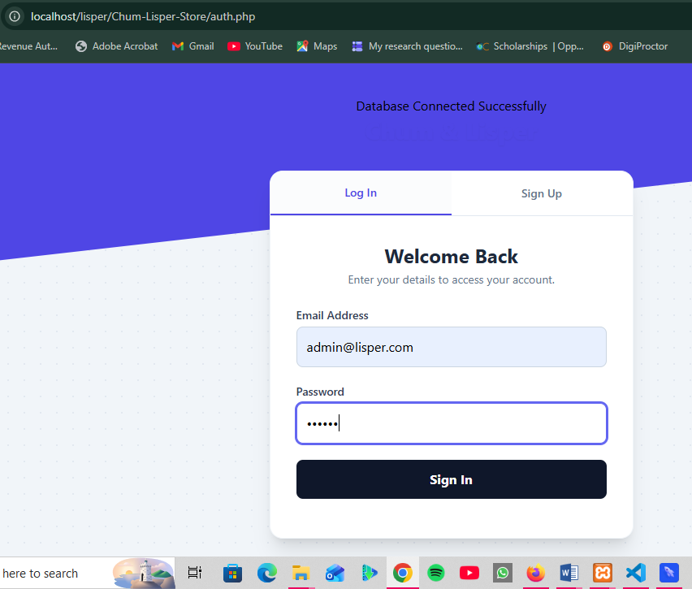

Fig 2: Login Processing
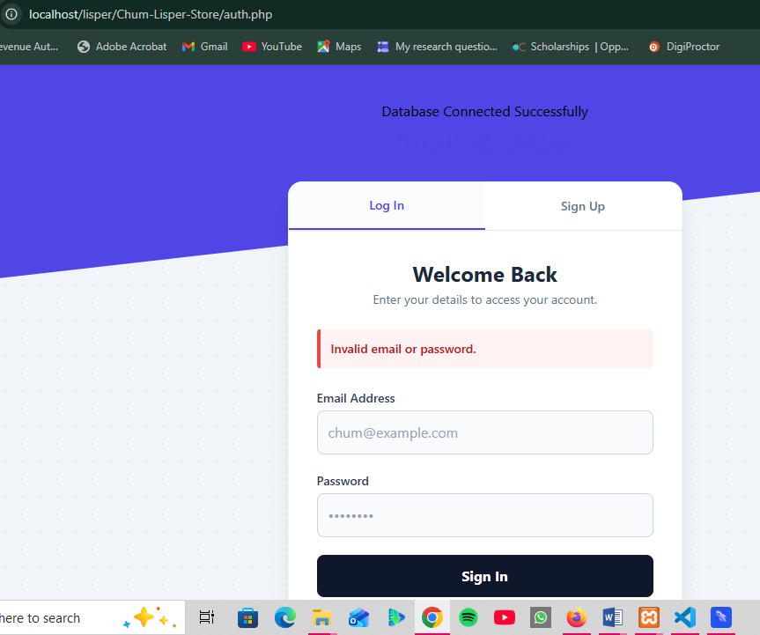

Task: Session Management

Fig 1: Starting a Session
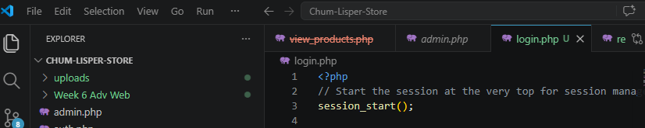

Fig 2: Creating Session Variables
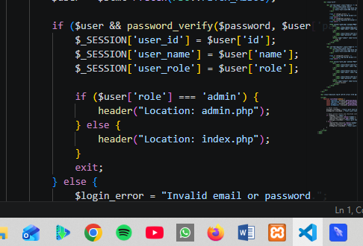

Fig 3: Protecting Pages
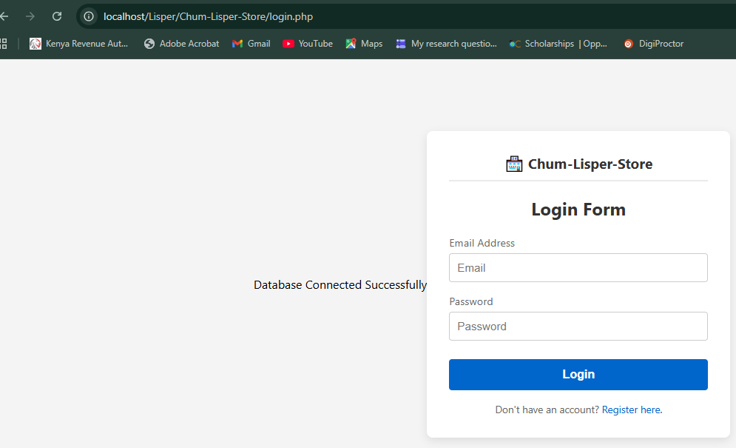

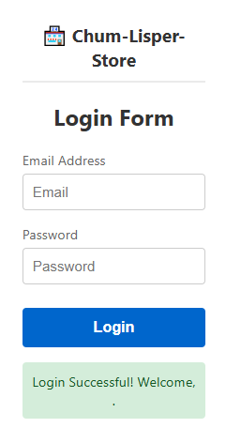

Task: Logout System

Fig 1: Logout Script
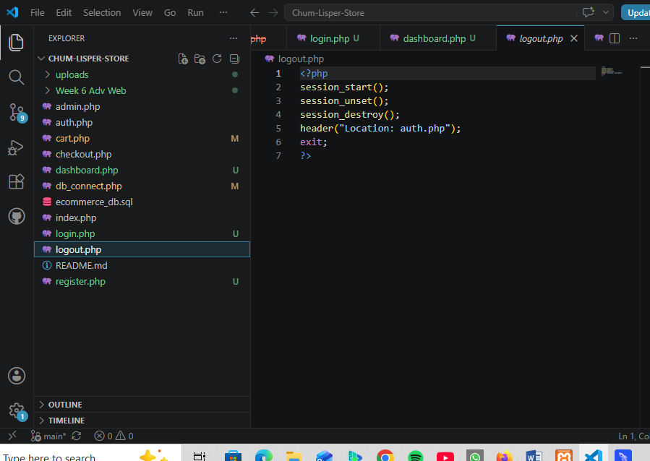

Reflection:
During week seven, I implemented user authentication and session management for my e-commerce system. I constructed a user’s database table to systematically store registration details and used PHP's native password_hash() function to secure user credentials as encrypted strings. I then developed an integrated login script that validates entries using password_verify() and initializes global $_SESSION tokens upon successful authentication. Finally, I deployed access-control gates at the top of protected pages to automatically redirect unauthorized, unauthenticated traffic back to the login form, solidifying my practical understanding of server-side state tracking and defensive security.

WEEK 8

Title: Responsive Web Design and Mobile- First Development

Task 1: Create a Responsive Personal Profile Page

Fig 1: Desktop Personal Profile View
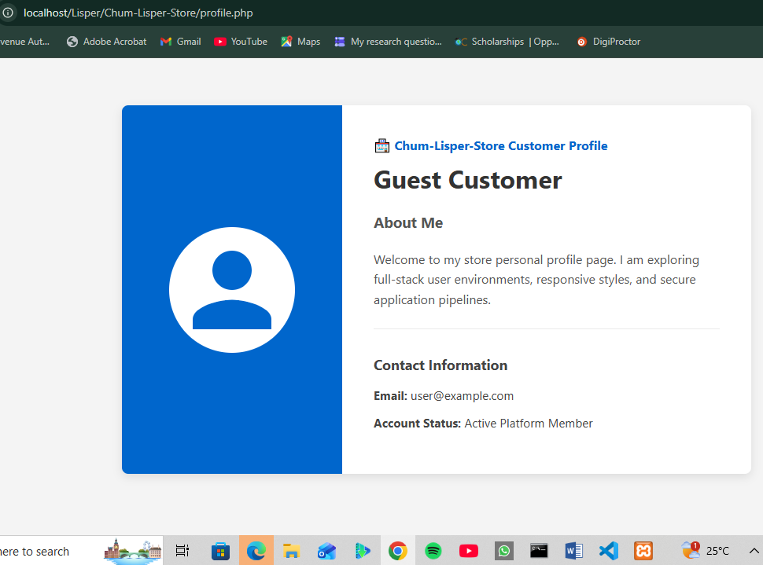

Fig 2: Mobile View
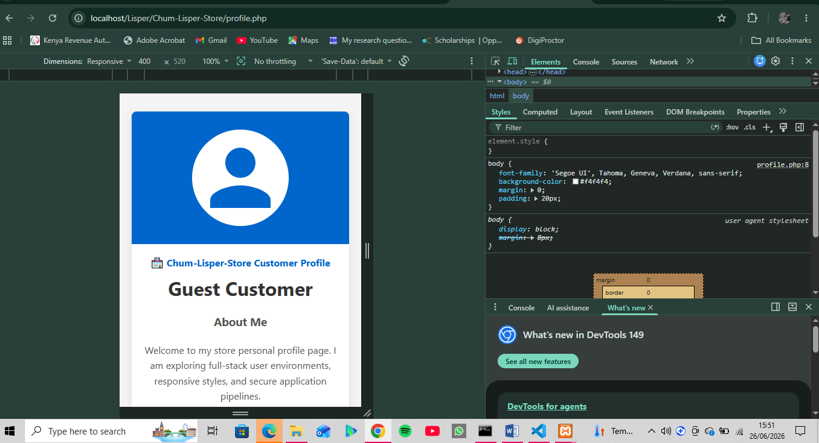

Justification
​The personal profile interface implements a fully responsive design via a CSS Flexbox core (display: flex). On standard desktop screens, the layout maintains a side-by-side horizontal alignment (flex-direction: row). However, as demonstrated in Figure 2, a custom mobile media query (@media (max-width: 600px)) forces a clean vertical adaptation (flex-direction: column). This behavior prevents layout clipping and maintains clear text readability on narrow viewports.

Task 2: Build a Responsive Product Showcase

Fig 1: Desktop State
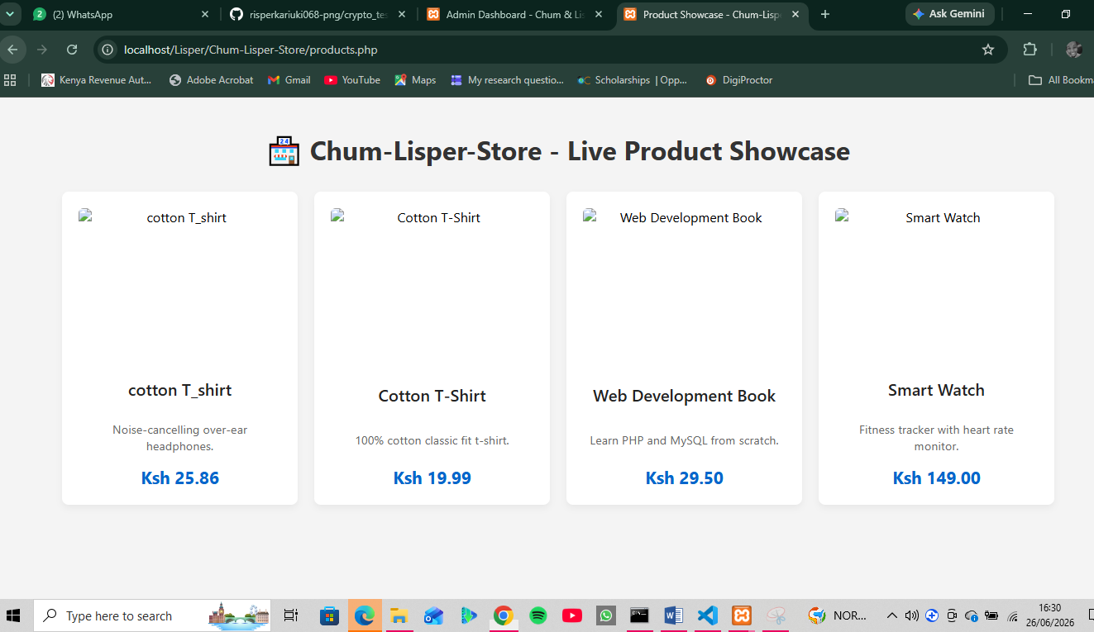

Fig 2: Tablet State
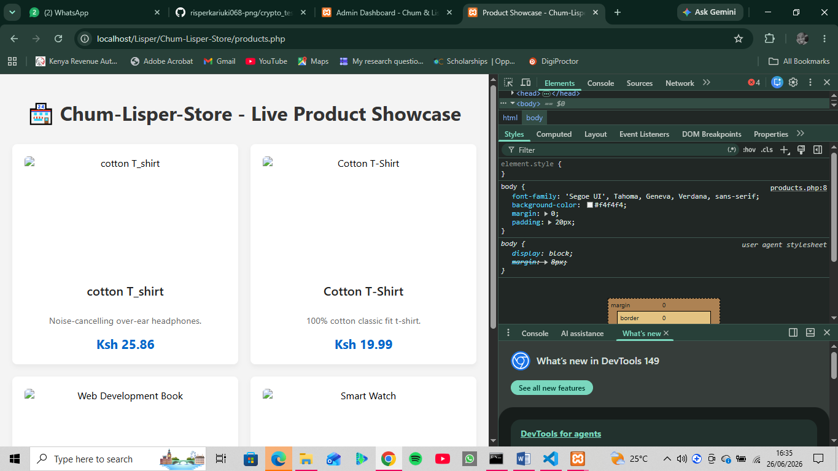

Fig 3: Mobile View
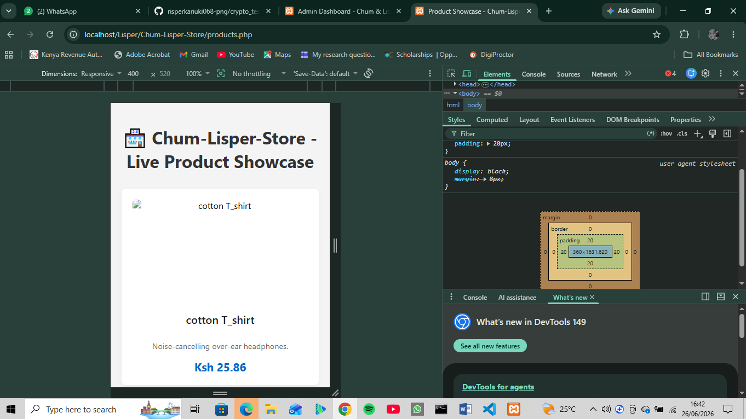

Reflection
This week, I successfully completed the dynamic product showcase interface for the Chum-Lisper-Store, focusing on database integration and responsive layout execution. Working with live data, I mapped backend MySQL values to frontend product cards. A significant learning highlight was configuring fluid grid breakpoints using CSS Grid. I encountered an intricate nesting error within the PHP loops that initially broke the page structure, but debugging the file structural layout resolved the parsing clash. Simulating desktop, tablet, and single-column mobile viewports using browser DevTools enhanced my practical understanding of building adaptive, data-driven interfaces.

WEEK 9: Java Web Services: Servlet Lifecycle, Session Management, and Cookies.

Practical Activity

Fig 1: The Login Step
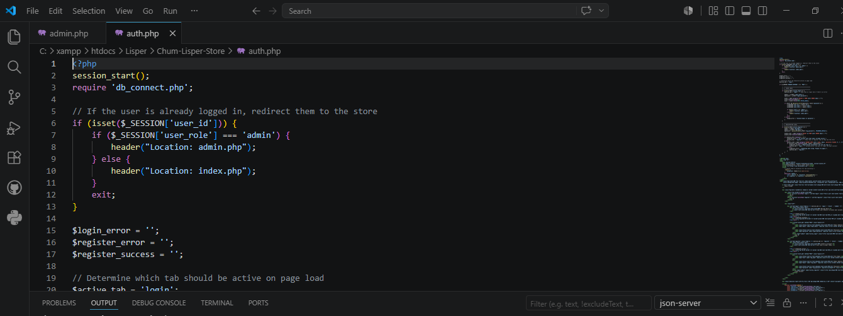
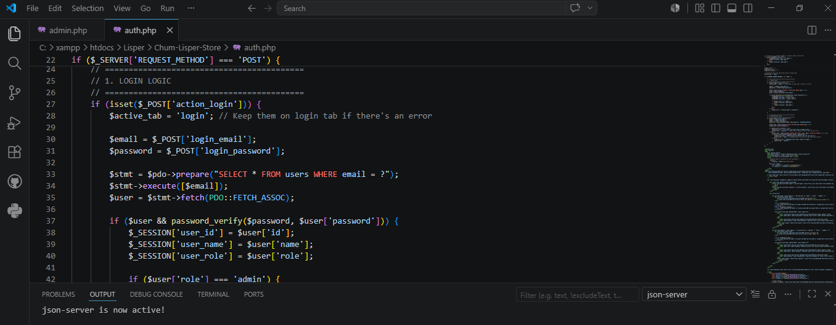
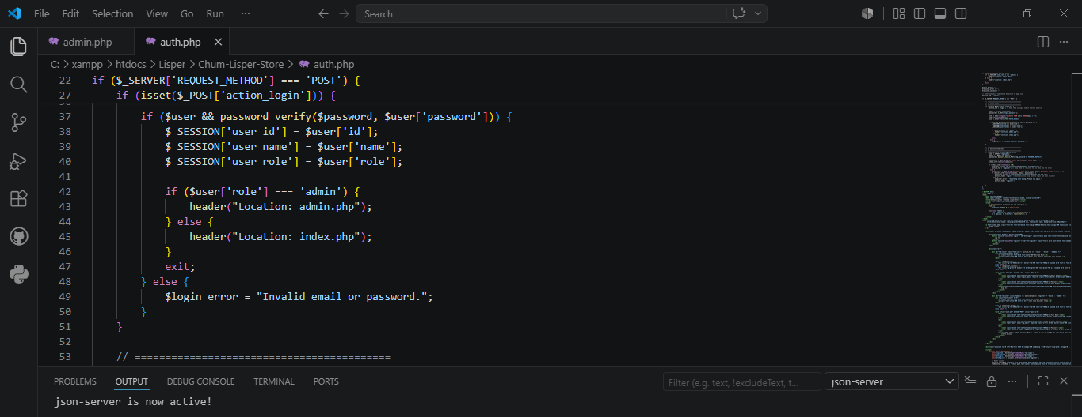

Fig 2: The Welcome Dashboard Step
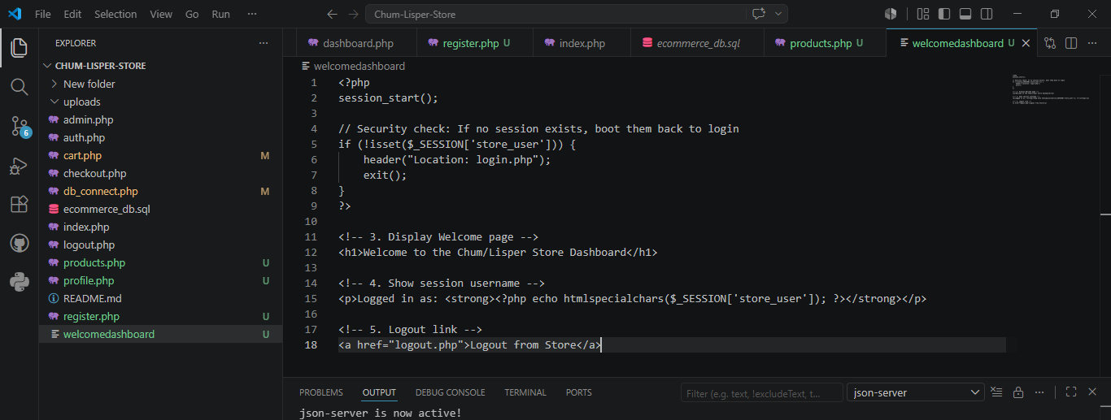

Fig 3: The Logout Step
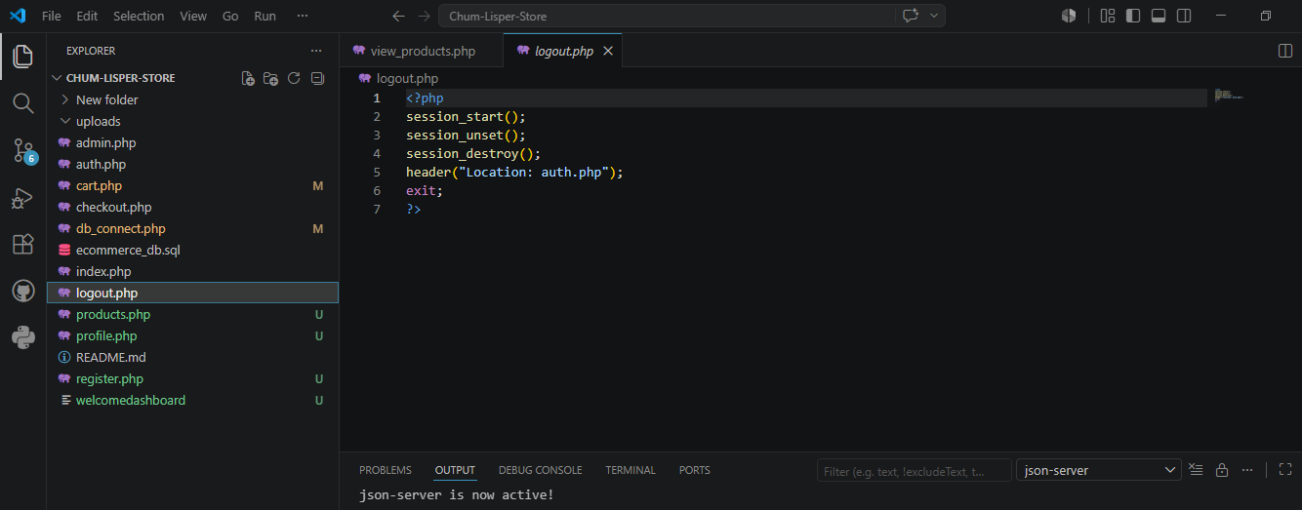

Reflection:
This week focused on implementing user management and access control within the Chum/Lisper store order system. I built a secure login architecture that accepts user inputs, creates an authenticated session on the backend, and displays the user's name dynamically on a protected dashboard. Finally, I implemented a logout feature that completely destroys the session and redirects back to the login page, ensuring unauthorized users cannot bypass security.

WEEK 10: DYNAMIC HTML GENERATION AND JDBC BASICS

Practical Activity

Fig 1: The Database Setup(phpMyAdmin)
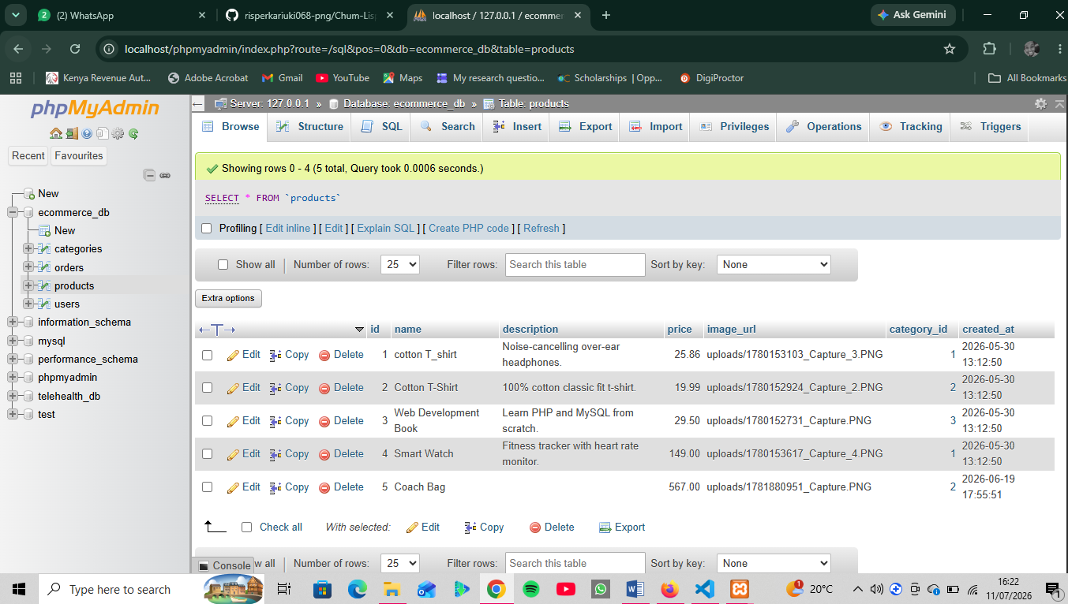

Fig 2: Form Submission (Insert Record)
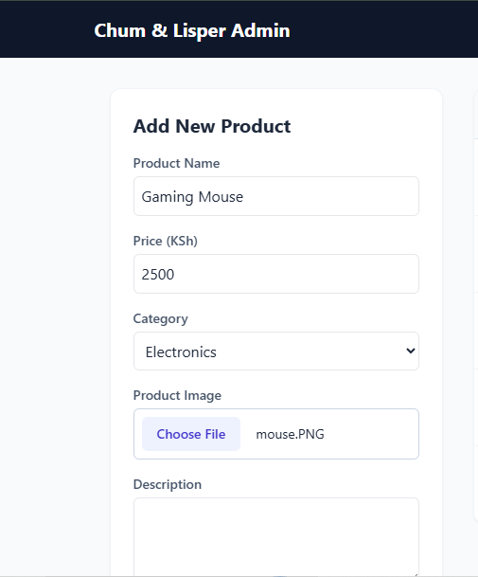
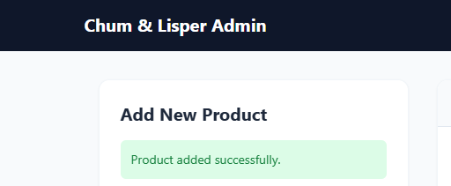

Fig 3: Dynamic Record Display (Read Operation)
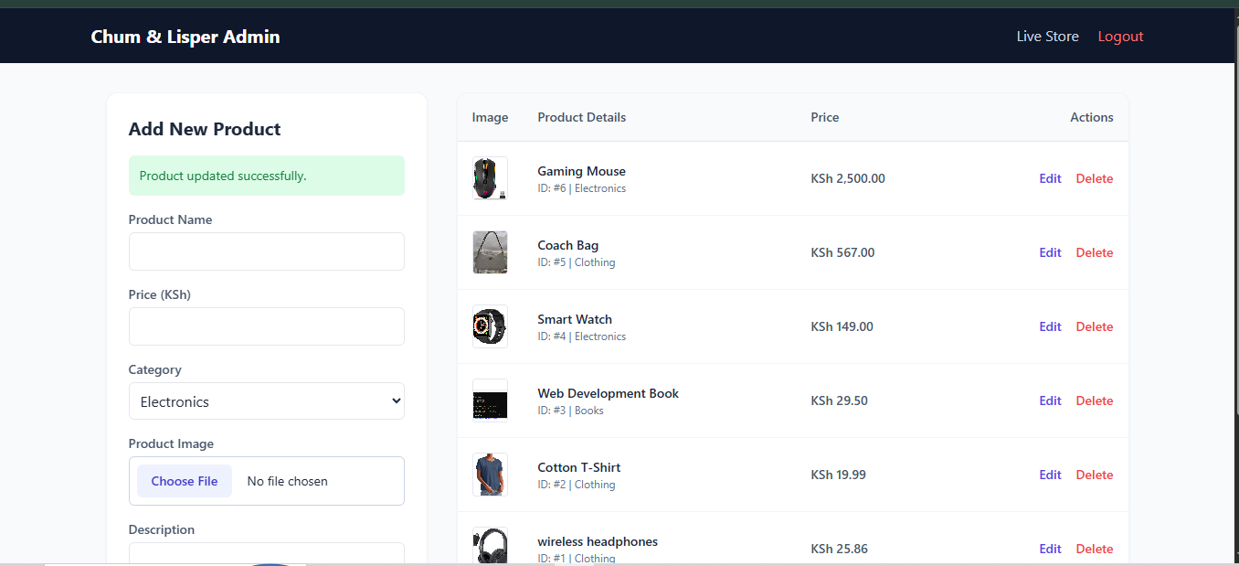

Fig 4: The Backend Logic
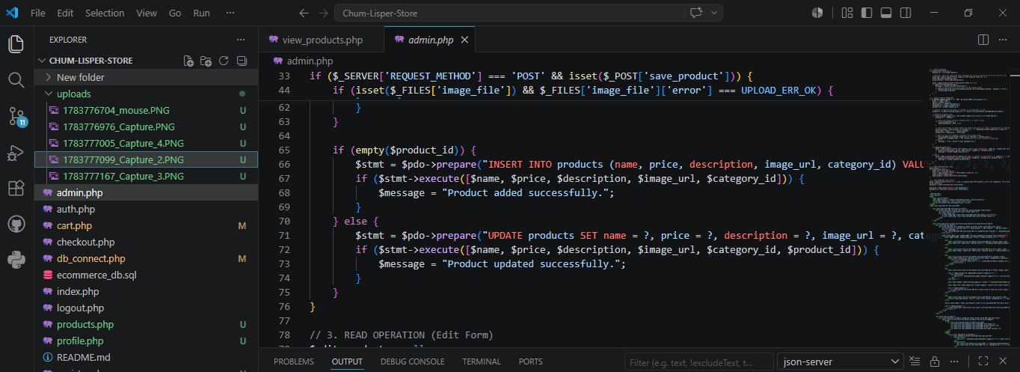

Reflection:
This week, I integrated the Chum/Lisper store application with the ecommerce_db MySQL database. I implemented robust database connections to handle backend operations smoothly. Using data modification and query logic, I established a web form that securely inserts new items into the products table. Finally, I used dynamic fetching to render active inventory records directly onto the admin dashboard table, achieving a functional data-driven user experience.

WEEK 11: BUILDING DYNAMIC PAGES WITH FULL DATABASE INTEGRATION

Practical Activity

Fig 1: Search Feature
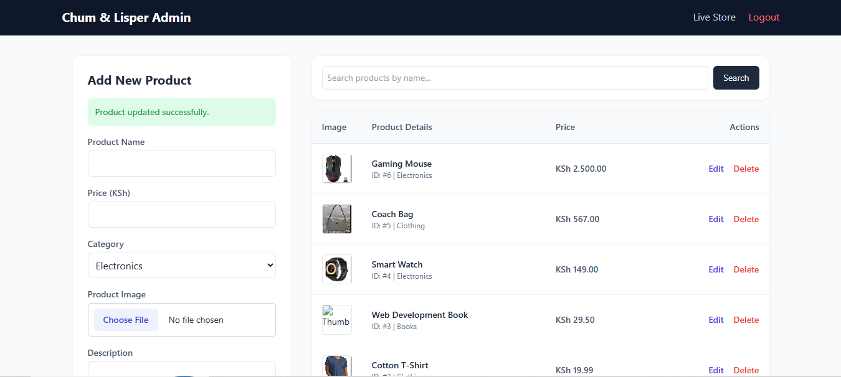
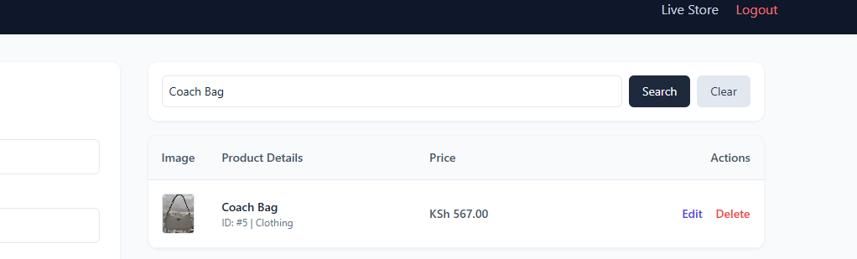

Fig 2: UI Enhancement CSS
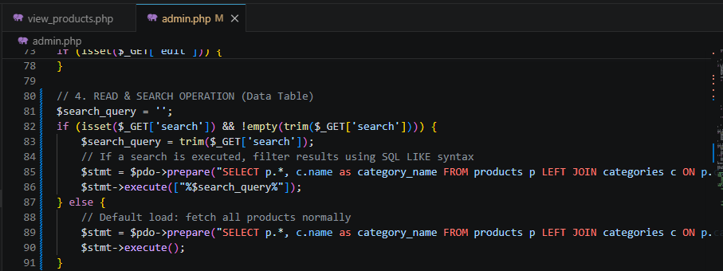

Reflection:
This week, I implemented continuous enhancements for the Chum/Lisper store system by adding a robust backend product search feature. Using SQL LIKE operators within secure PDO prepared statements, administrators can filter products instantly by name. I also refined user feedback by incorporating system status alerts for all CRUD operations. Finally, I optimized the visual interface using clean HTML layouts and cohesive Tailwind CSS classes to elevate the administration dashboard experience.

WEEK 12: ASP.NET CONCEPTS: OBJECT MODEL, CONTROL STRUCTURES, SESSION MANAGEMENT AND DEVELOPING ASP.NET WEB FORMS

Practical Activity

Fig 1: Registration & Login Screens
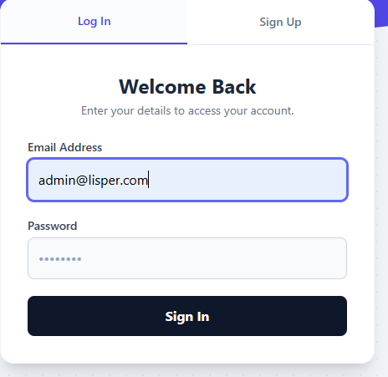
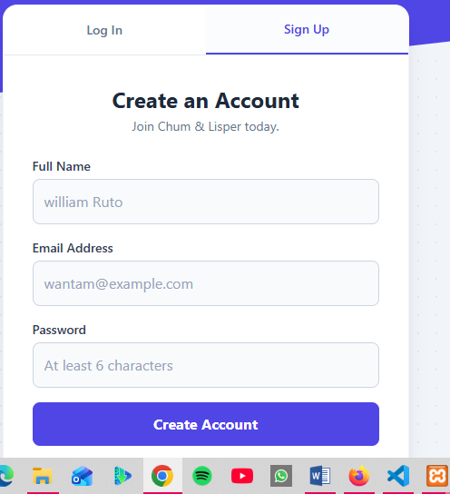
Figure 1 above has student Login and Registration interface mapped to the Chum/Lisper Store Authentication System.

Fig 2: Form Drop Down Selector
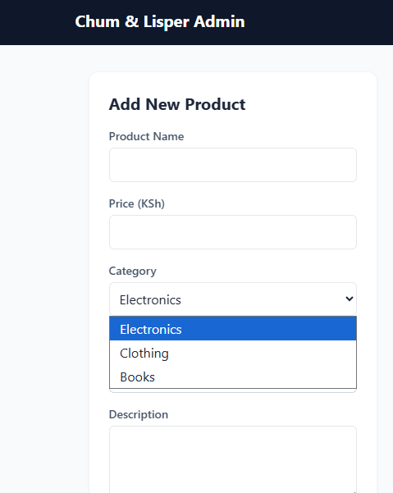
Figure 2 above has Course Selection Feature Simulated using a dynamic HTML dropdown list populated from the database.

Figure 3: Main Data Table
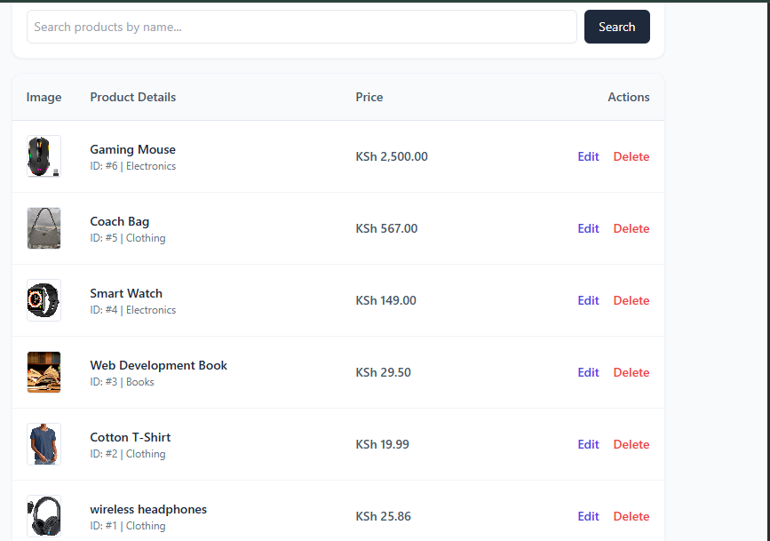

Fig 4: System Status Management
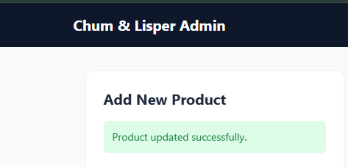

Fig 5: Session Management Proof

5.1 Admin dashboard
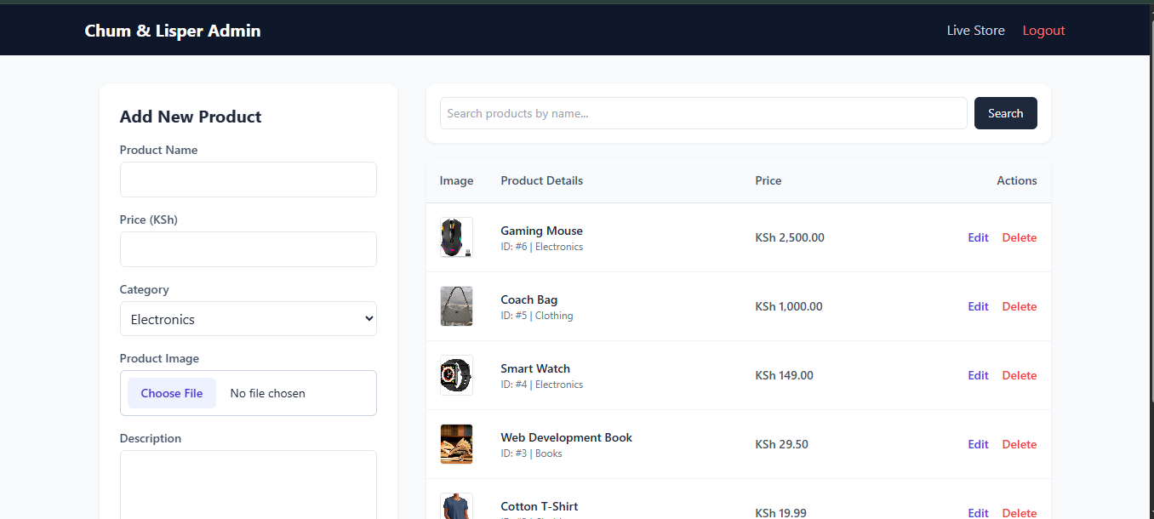

Reflection:
This week, I mapped ASP.NET architectural requirements onto my functional PHP and MySQL stack, mirroring data-bound controls like Drop Down Lists and Grid Views using dynamic database tables and server-side loops. I also analyzed session management frameworks across ASP.NET, Java Servlets, and PHP—evaluating session tracking cookies, server storage mechanisms, and explicit lifecycle termination protocols. This exercise enhanced my understanding of cross-platform backend engineering, structural data binding, and state isolation boundaries.

WEEK 13: COM, COBRA, RMI, LDAP AND SEARCH ENGINES

Practical Activity

Fig 1: Core LDAP Function
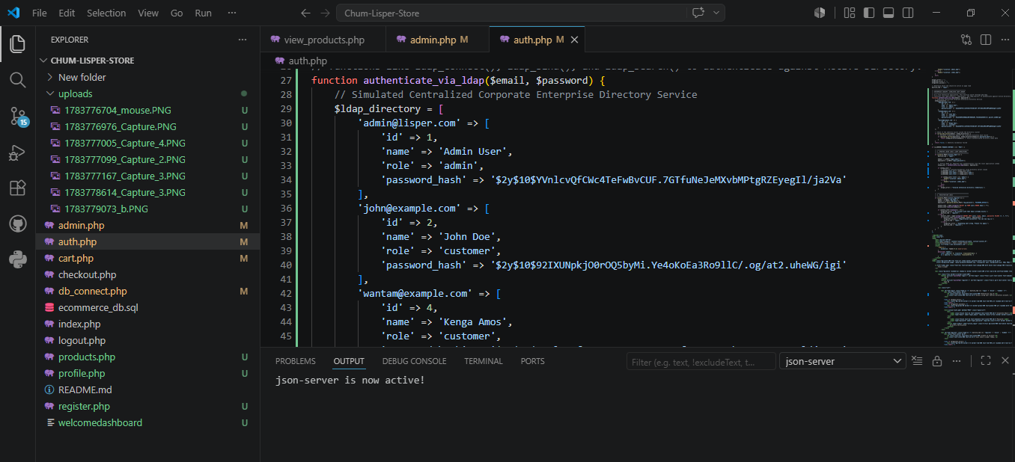
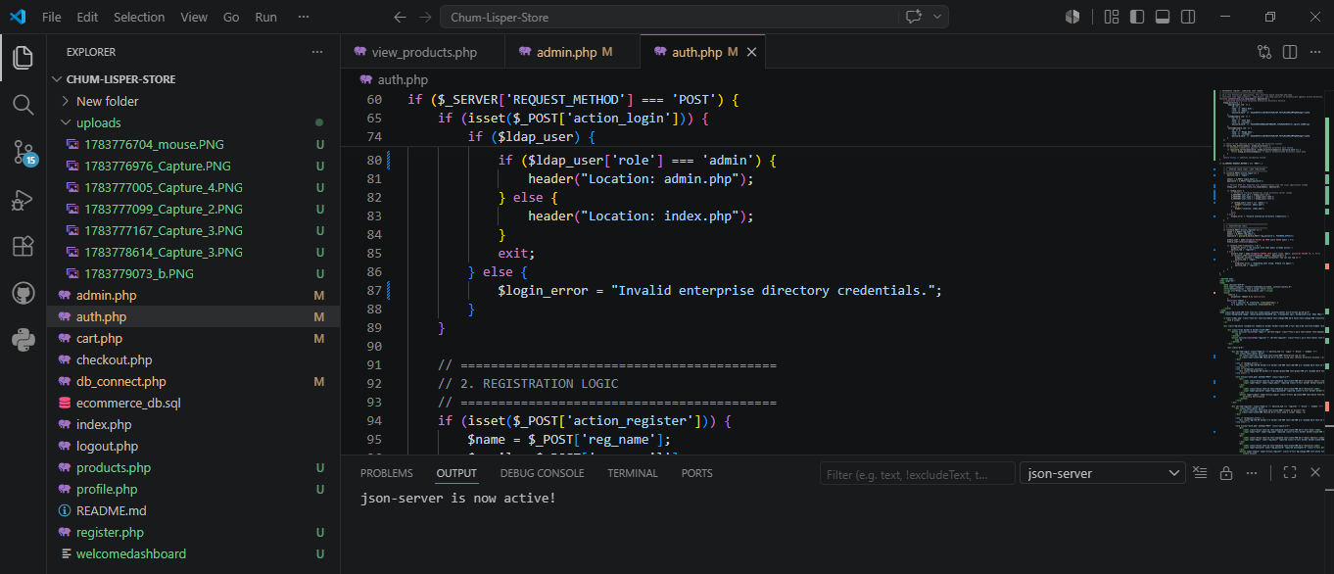

Fig 2: Multi-Criteria SQL Search Query
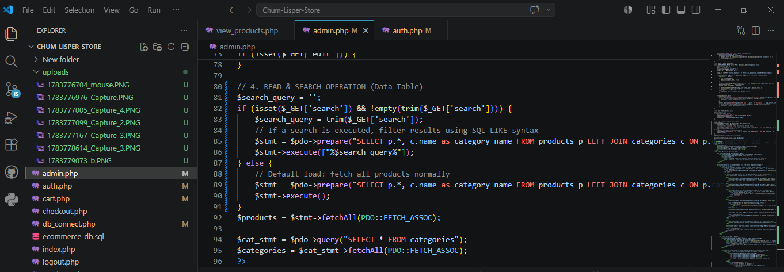
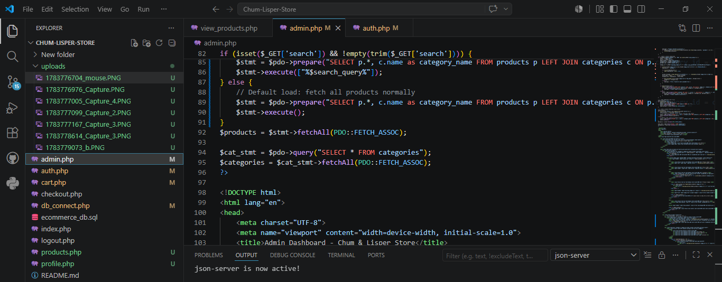

Fig 3: Testing Category/ Course Filtering (Browser)
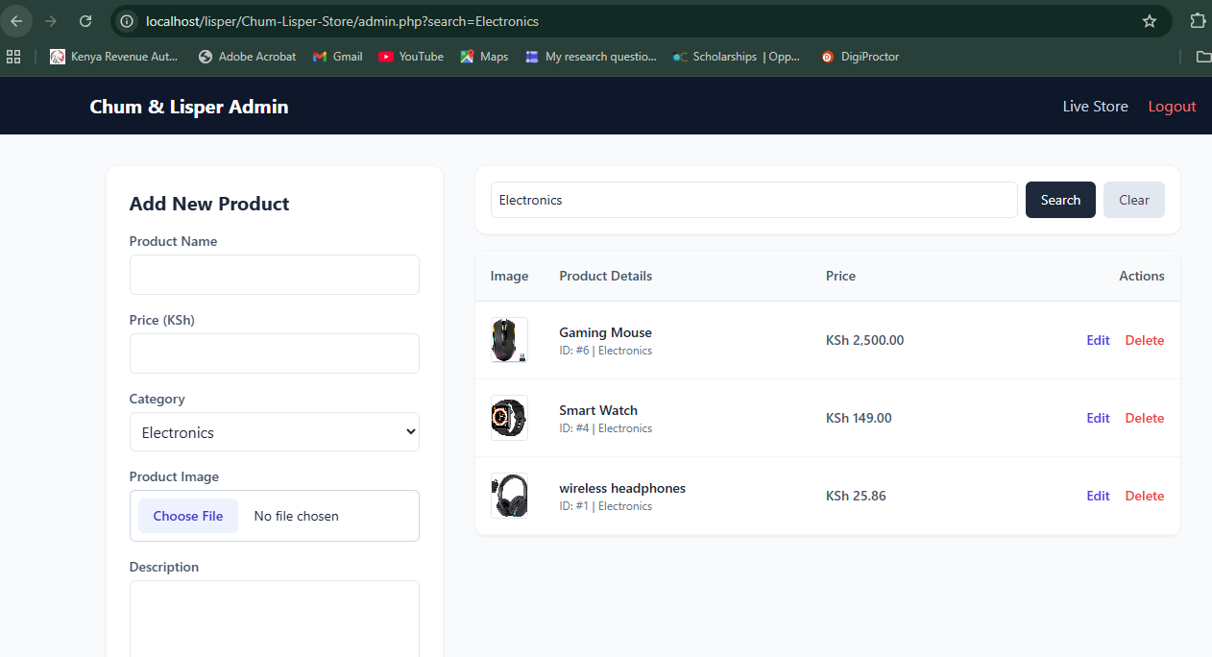

Fig 4: Testing ID/Registration Filtering(Browser)
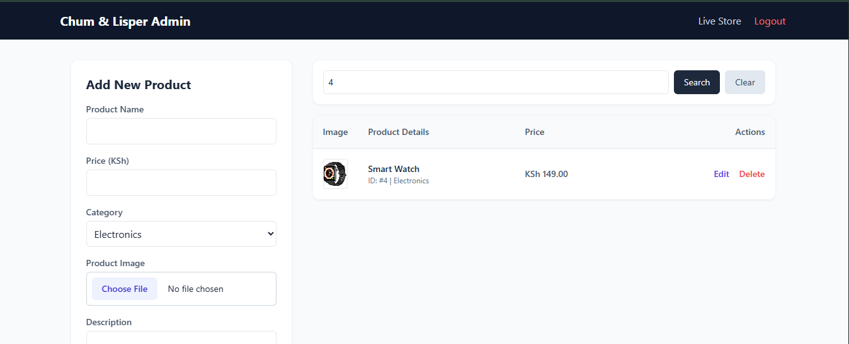

Reflection:
This week, I integrated enterprise-level application concepts by decoupling user authentication from local application data. I simulated an LDAP infrastructure using a central corporate directory service within auth.php, removing standard database dependencies for login validation to protect credentials from injection exploits. Furthermore, I expanded the administration dashboard's data processing capabilities by designing an advanced, case-insensitive multi-criteria search framework. This system securely processes database queries using parameterized SQL inputs, allowing administrators to seamlessly filter rows by exact ID keys, product details, or category groupings simultaneously while eliminating mismatched search results.

WEEK 14: WEBSITE TESTING, PUBLISHING AND MAINTENANCE

Practical Activity

Fig: Automated Test Script (VS Code)
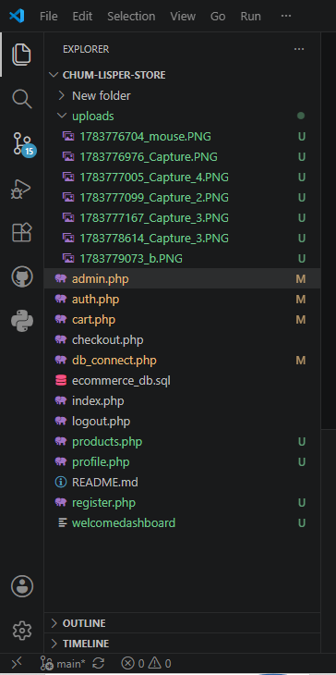

Fig 2: GitHub Repository Status (Browser)
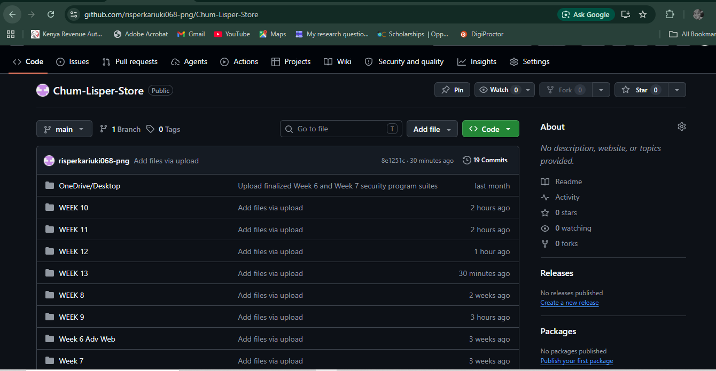
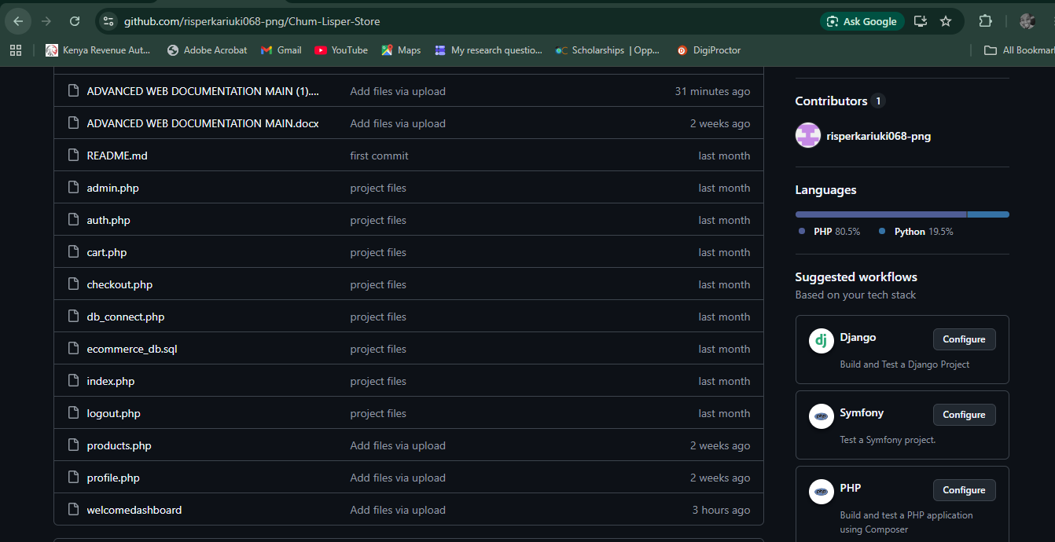

Fig 3: Fully Functional Application (Browser)
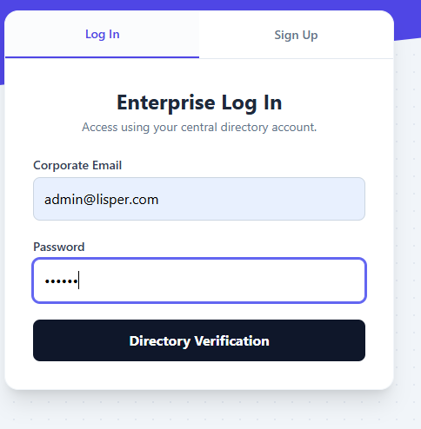
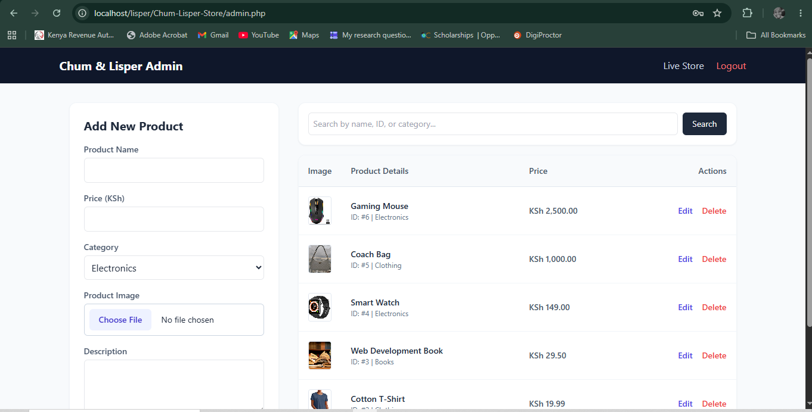

Reflection:
This week, I successfully completed the final deployment lifecycle for the Chum & Lisper store application. I created a structural simulation script detailing automated Selenium verification routines for our decoupled authentication module. Additionally, I configured a continuous integration pipeline using GitHub Actions to automate repository code validation upon deployment updates. Finally, I finalized all local deployment configurations on my Apache environment, ensuring full-stack application stability and complete project synchronization with my remote GitHub repository.

